
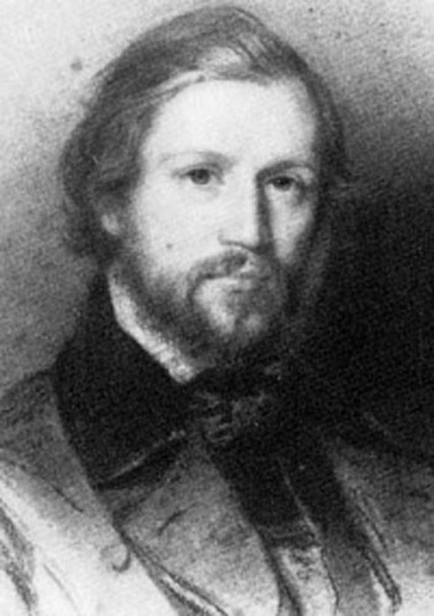

Charles-Valentin Alkan (30 November 1813 – 29 March 1888)

Alkan was born Charles-Valentin Morhange in Paris to Alkan Morhange (1780–1855) and Julie Morhange, née Abraham. Alkan Morhange was descended from a long-established Jewish Ashkenazic community in the region of Metz the village of Morhange is located about 30 miles (48 km) from the city of Metz.
Alkan was a child prodigy. He entered the Conservatoire de Paris at an unusually early age, and studied both piano and organ. The records of his auditions survive in the Archives Nationales in Paris. At his solfège audition on 3 July 1819, when he was just over 5 years 7 months, the examiners noted Alkan (who is referred to even at this early date as "Alkan (Valentin)", and whose age is given incorrectly as six-and-a-half) as "having a pretty little voice". The profession of Alkan Morhange is given as "music-paper ruler". At Charles-Valentin's piano audition on 6 October 1820, when he was nearly seven (and where he is named as "Alkan (Morhange) Valentin"), the examiners comment "This child has amazing abilities."
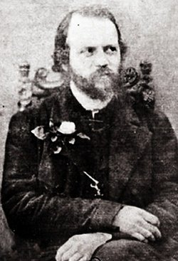
Alkan became a favourite of his teacher at the Conservatoire, Joseph Zimmermann, who also taught Georges Bizet, César Franck, Charles Gounod, and Ambroise Thomas. At the age of seven, Alkan won a first prize for solfège and in later years prizes in piano (1824), harmony (1827), and organ (1834). At the age of seven-and-a-half he gave his first public performance, appearing as a violinist and playing an air and variations by Pierre Rode. Alkan's Opus 1, a set of variations for piano based on a theme by Daniel Steibelt, dates from 1828, when he was 14 years old.
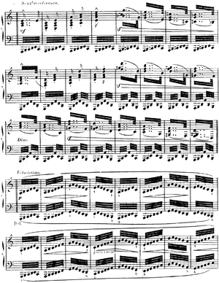
From about 1826 Alkan began to appear as a piano soloist in leading Parisian salons, including those of the Princesse de la Moskova (widow of Marshal Ney), and the Duchesse de Montebello. He was probably introduced to these venues by his teacher Zimmermann. At the same time, Alkan Morhange arranged concerts featuring Charles-Valentin at public venues in Paris, in association with leading musicians including thesopranos Giuditta Pasta and Henriette Sontag, the cellist Auguste Franchomme and the violinist Lambert Massart, with whom Alkan gave concerts in a rare visit out of France to Brussels in 1827. In 1829, at the age of 15, Alkan was appointed joint professor of solfège – among his pupils in this class a few years later was his brother Napoléon. In this manner Alkan's musical career was launched well before the July Revolution of 1830, which initiated a period in which "keyboard virtuosity ... completely dominated professional music making" in the capital, attracting from all over Europe pianists who, as Heinrich Heine wrote, invaded "like a plague of locusts swarming to pick Paris clean." Alkan nonetheless continued his studies and in 1831 enrolled in the organ classes of François Benoist, from whom he may have learnt to appreciate the music of Johann Sebastian Bach, of whom Benoist was then one of the few French advocates.
In 1832 Alkan took the solo role in his first Concerto da camera for piano and strings at the Conservatoire. In the same year, aged 19, he was elected to the influential Société Académique des Enfants d'Apollon (Society of the Children of Apollo), whose members included Luigi Cherubini, Fromental Halévy, the conductorFrançois Habeneck, and Liszt, who had been elected in 1824 at the age of twelve. Between 1833 and 1836 Alkan participated at many of the Society's concerts. Alkan twice competed unsuccessfully for the Prix de Rome, in 1832 and again in 1834; the cantatas which he wrote for the competition, Hermann et Ketty and L'Entrée en loge, have remained unpublished and unperformed.
In 1834 Alkan began his friendship with the Spanish musician Santiago Masarnau, which was to result in an extended and often intimate correspondence which only came to light in 2009. Like virtually all of Alkan's correspondence, this exchange is now one-sided; all of his papers (including his manuscripts and his extensive library) were either destroyed by Alkan himself, as is clear from his will, or became lost after his death. Later in 1834 Alkan made a visit to England, where he gave recitals and where the second Concerto da camera was performed in Bath by its dedicatee Henry Ibbot Field; it was published in London together with some solo piano pieces. A letter to Masarnau and a notice in a French journal that Alkan played in London with Moscheles and Cramer, indicate that he returned to England in 1835. Later that year, Alkan, having found a place of retreat at Piscop outside Paris, completed his first truly original works for solo piano, the Twelve Caprices, published in 1837 as Opp. 12, 13, 15 and 16. Op. 16, the Trois scherzi de bravoure, is dedicated to Masarnau. In January 1836, Liszt recommended Alkan for the post of Professor at the Geneva Conservatoire, which Alkan declined,and in 1837 he wrote an enthusiastic review of Alkan's Op. 15 Caprices in the Revue et gazette musicale.
From 1837, Alkan lived in the Square d'Orléans in Paris, which was inhabited by numerous celebrities of the time including Marie Taglioni,Alexandre Dumas, George Sand, and Chopin. Chopin and Alkan were personal friends and often discussed musical topics, including a work on musical theory that Chopin proposed to write. By 1838, at 25 years old, Alkan had reached a peak of his career.
Alkan's attachment to his Jewish origins is displayed both in his life and his work. He was the first composer to incorporate Jewish melodies in art music. Fluent in Hebrew and Greek, he devoted much time to a complete new translation of the Bible into French. This work, like many of his musical compositions, is now lost. Alkan never married, but his presumed son Élie-Miriam Delaborde was, like Alkan, a virtuoso performer on both the piano and the pedal piano, and edited a number of the elder composer's works.
Following his death (which according to persistent but unfounded legend was caused by a falling bookcase) Alkan's music became neglected, supported by only a few musicians including Ferruccio Busoni, Egon Petri and Kaikhosru Sorabji. From the late 1960s onwards, led by Raymond Lewenthal and Ronald Smith, many pianists have recorded his music and brought it back into the repertoire.
Materials were used: http://en.wikipedia.org/wiki/Charles-Valentin_Alkan

